Here are my java Library Management System codes:

This project has three class:  
Library (main)

Book

CustomFunctions

**Library Class Code:**

import java.util.Scanner;

import java.util.HashMap;

import java.util.Map;

class Library { // Created a Library Class

    private Map<String, Book> library;

    public Library() { // Constructor

        library = new HashMap<>(); // Assign new empty HashMap to library variable

    }

    public void addBook(String BookTitle, String BookAuthor, int quantity) { // Function to add book to the library

        if (library.containsKey(BookTitle)) { // Checks if book is available or not

            Book existingBook = library.get(BookTitle);

            existingBook.setQuantity(existingBook.getQuantity() + quantity); // Updating existing book quantity

            System.out.println("Bood Already Exists, Quantity Updated.");

        } else {

            library.put(BookTitle, new Book(BookTitle, BookAuthor, quantity)); // Adds new Book

            System.out.println("Successfully Book added.");

        }

    }

    public void borrowBook(String BookTitle, int bookQuantityToBorrow) { // Function to Borrow book

        if (library.containsKey(BookTitle)) { // Checking if book is available or not

            Book book = library.get(BookTitle);

            int availableBookQuantity = book.getQuantity();

            System.out.println(availableBookQuantity);

            int borrowedBookQuantity = book.getborrowedBookQuantity();

            if (availableBookQuantity >= bookQuantityToBorrow) { // Checking borrow book quantity is available or not

                book.setQuantity(availableBookQuantity - bookQuantityToBorrow); // Updating book quantity

                book.setborrowedBookQuantity(borrowedBookQuantity + bookQuantityToBorrow); // Updating Borrow book

                                                                                           // quantity

                System.out.println(bookQuantityToBorrow + " copies of '" + BookTitle + "' borrowed successfully.");

            } else {

                System.out

                        .println("Sorry! Only " + availableBookQuantity + " '" + BookTitle + "' Books are available.");

            }

        } else {

            System.out.println("Sorry! Your Requested '" + BookTitle + "' book is not available.");

        }

    }

    public void returnBook(String BookTitle, int quantityOfBookToReturn) { // Function to return Book

        if (library.containsKey(BookTitle)) { // Checks if return book available in library or not

            Book book = library.get(BookTitle);

            int bookQuantity = book.getQuantity();

            int borrowedBookQuantity = book.getborrowedBookQuantity();

            if (borrowedBookQuantity >= quantityOfBookToReturn) { // Checking if borrowed book quantity is greater or

                                                                  // equall to return quantity book

                book.setQuantity(bookQuantity + quantityOfBookToReturn); // Updating book quantity

                book.setborrowedBookQuantity(borrowedBookQuantity - quantityOfBookToReturn); // Updating Borrow book

                System.out.println(quantityOfBookToReturn + " '" + BookTitle + "' Books returned successfully.");

            } else {

                System.out.println("This Quantity is more than you borrowed. Please Enter correct number.");

            }

        } else {

            System.out.println("'" + BookTitle + "' is not available in the Library.");

        }

    }

    public void displayBooks() { // Function to display Books

        if (library.size() == 0) {

            System.out.println("No Books Available in Library:");

        } else {

            System.out.println("Available Books: ");

            for (Book book : library.values()) {

                System.out.println(book);

            }

        }

    }

    public static void main(String[] args) {

        Library library = new Library(); // Create Library Object

        CustomFunctions fn = new CustomFunctions(); // Create CustomFunctions Object

        try { // handling Errors

            Scanner sc = new Scanner(System.in);

            while (true) { // Runs untill user want to exit

                System.out.println(

                        "\n\t\t\t#####**************************     1: Display Books     **************************#####");

                System.out.println(

                        "\t\t\t#####**************************     2: Add Book          **************************#####");

                System.out.println(

                        "\t\t\t#####**************************     3: Borrow Book       **************************#####");

                System.out.println(

                        "\t\t\t#####**************************     4: Return Book       **************************#####");

                System.out.println(

                        "\t\t\t#####**************************     5: Exit              **************************#####");

                char choice = sc.next().charAt(0);

                switch (choice) {

                    case '1':

                        library.displayBooks();

                        break;

                    case '2':

                        library.addBook(fn.getBookTitleFromUser(), fn.getAuthorNameFromUser(),

                                fn.getQuantityFromUser());

                        break;

                    case '3':

                        library.borrowBook(fn.getBookTitleFromUser(), fn.getQuantityFromUser());

                        break;

                    case '4':

                        library.returnBook(fn.getBookTitleFromUser(), fn.getQuantityFromUser());

                        break;

                    case '5':

                        System.exit(0);

                        break;

                    default:

                        System.out.println("Invalid Input!!!");

                        break;

                }

            }

        } catch (Exception e) {

            throw new Error("Error : " + e.getMessage());

        }

    }

}

**Book Class Codes:**

class Book { // Book Class

    private String BookTitle;

    private String BookAuthor;

    private int quantity;

    private int borrowedBookQuantity;

    public Book(String BookTitle, String BookAuthor, int quantity) { // Book Constructor

        this.BookTitle = BookTitle;

        this.BookAuthor = BookAuthor;

        this.quantity = quantity;

    }

    public String getBookTitle() { // Function to return book Book Title

        return BookTitle;

    }

    public String getBookAuthor() { // Function to return book BookAuthor

        return BookAuthor;

    }

    public int getQuantity() { // Function to return book quantity

        return quantity;

    }

    public int getborrowedBookQuantity() { // Function to return borrowed book quantity

        return borrowedBookQuantity;

    }

    public void setQuantity(int BookQuantity) { // set Book quantity

        this.quantity = BookQuantity;

    }

    public void setborrowedBookQuantity(int BorrowedBookQuantity) { // set borrowed Book quantity

        this.borrowedBookQuantity = BorrowedBookQuantity;

    }

    @Override

    public String toString() { // Function to return books detail in same pattern

        return BookTitle + " by " + BookAuthor + " (Quantity: " + quantity + ")";

    }

}

**CustomFunctions Class Codes:**

import java.util.Scanner;

class CustomFunctions { // CustomFunctions Class

    public String getBookTitleFromUser() {

        Scanner scanner = new Scanner(System.in); // Function to get book title from user and return it

        try {

            System.out.println("\n\n\t\t\t Enter Book Title : ");

            return scanner.nextLine();

        } catch (Exception e) {

            System.out.println("Error: " + e.getMessage());

            return "";

        }

    }

    public String getAuthorNameFromUser() { // Function to get book Author name from user and return it

        try {

            System.out.println("\n\n\t\t\t Enter Author Name : ");

            Scanner scanner = new Scanner(System.in);

            return scanner.nextLine();

        } catch (Exception e) {

            System.out.println("Error: " + e.getMessage());

            return "";

        }

    }

    public int getQuantityFromUser() { // Function to get book Quantity from user and return

        try {

            System.out.println("\n\n\t\t\t Enter Book Quantity : ");

            Scanner scanner = new Scanner(System.in);

            return scanner.nextInt();

        } catch (Exception e) {

            System.out.println("Error: " + e.getMessage());

            return 0;

        }

    }

}

**Output Screenshots:**

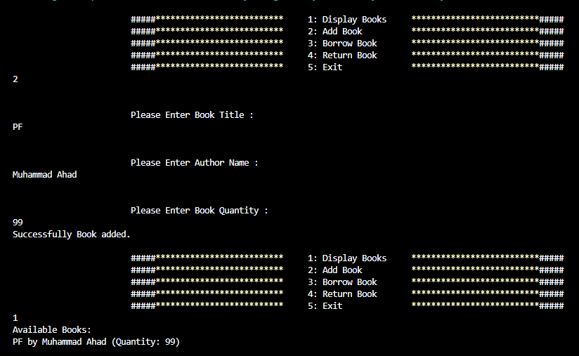

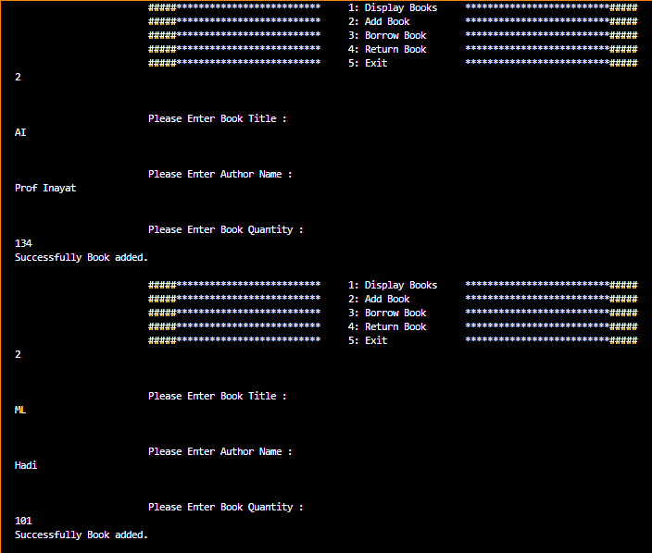

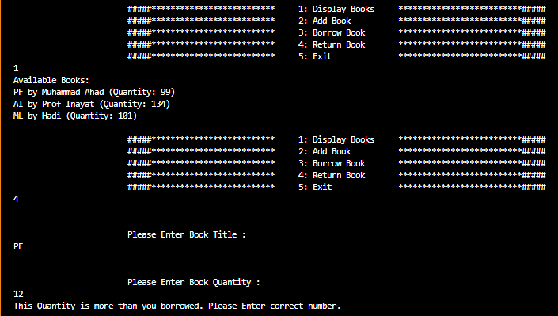

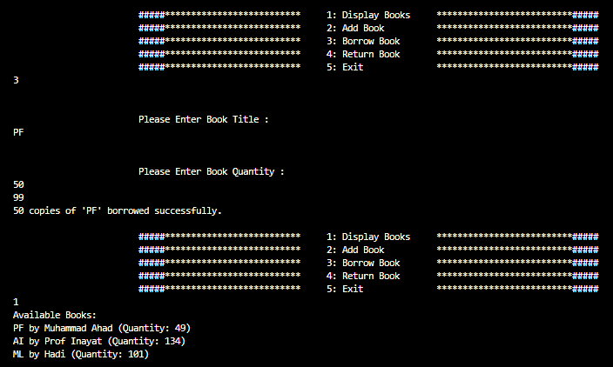

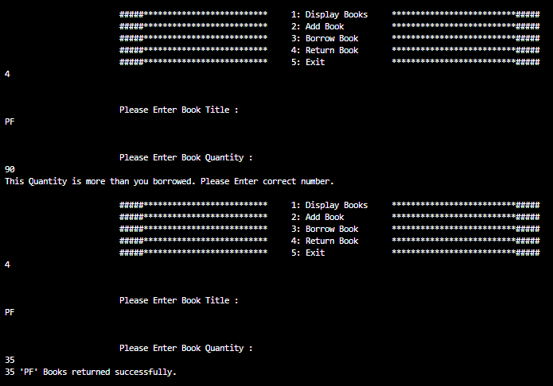  
  
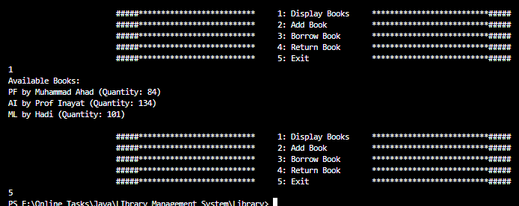

**The End**